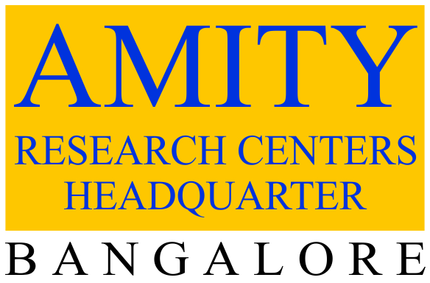

**Annexure I**

**Amity Prize Winning Cases in International Case Competitions**

|  |  |  |
| --- | --- | --- |
| **Sl. No.** | **Title of the Award-Winning Cases** | **Competition** |
|  | Maersk’s Pursuit of Maritime Sustainability: A Dream or Reality? | John Molson MBA International Case Competition 2025 – 1st Prize |
|  | ChatGPT: The Future of AI? | The Case Centre Awards and Competitions 2024 – Knowledge, Information and Communication Systems Management category Award |
|  | NFTs: The Booming World of Digital Assets | The Case Centre Awards and Competitions 2023 – Economics, Politics and Business Environmentcategory Award |
|  | First Women’s Bank: A Step Towards an Inclusive Economy | HEC Montreal CSR Case Writing Competition 2023 – 3rd Prize |
|  | Sentient AI: Will They Overtake Their Creators? | John Molson MBA International Short Case Competition 2023 – Runner-up |
|  | Instacart’s Evolving Business Model: A Sustainable Growth Strategy? | John Molson MBA International Case Competition 2022 – Runner-up |
|  | Sustainability International’s Alliance with ConsenSys – Leveraging Technology for Social Impact | oikos International Case Writing Competition 2018 - Social Entrepreneurship Track – Runner-up |
|  | Modest Fashion: Will It Divide What Was United by Faith? | EFMD Case Writing Competition 2017 – ‘MENA Business Cases’ Category Award |
|  | The Dollar Shave Club: Can the Unilever Deal Add Sheen | John Molson MBA International Case Competition 2017 – 3rd Prize |
|  | Luxury Retailer Louis Vuitton in China: Losing Lustre or Adding Colour? | Global Best China-Focused Cases 2015 by China Europe International Business School (CEIBS) – Nominated Award |
|  | Yum! Brands in China: Facing Brand Fatigue? | Global Best China-Focused Cases 2015 by China Europe International Business School (CEIBS) – Nominated Award |
|  | Warby Parker: ‘One-for-One’ Model in Eyewear | John Molson MBA International Case Competition 2015 – 3rd Prize |
|  | Arunachalam Muruganantham: A Social Entrepreneur Innovating in a Woman’s World | oikos International Case Writing Competition 2015 - Social Entrepreneurship Track – 3rd Prize |
|  | MokshaYug Access (MYA) in India: Enriching India’s Dairy Farmers | oikos International Case Writing Competition 2014 - Social Entrepreneurship Track – Runner-up |
|  | Duolingo: A De facto Language Tutor? | 6th AESE International Case Competition 2015 – among the top seven. |
|  | Philips’ Transition to Circular Economy: Can the Innovation Sustain? | 6th AESE International Case Competition 2015 – among the top seven |
|  | City Football Group: Crafting an Innovative Business Model | 6th AESE International Case Competition 2015 – among the top seven |
|  | Practo: Transforming Healthcare Dynamics with Technology | 6th AESE International Case Competition 2015 – among the top seven |
|  | Mattel Inc – Making Innovations with Max Steel to Keep Barbie Spirit Alive | 4th AESE International Case Competition 2013 – among the top seven |